**CAPSTONE PROJECT**

# SECURE DATA HINDING IN IMAGES USING STEGANOGRAPHY

**Presented By: Barigela Sathishkumar**

**College Name:**

**RV Institute of Technology**

**Department :MCA**

**OUTLINE**

* **Problem Statement**
* **Technology used**
* **Wow factor**
* **End users**
* **Result**
* **Conclusion**
* **Git-hub Link**
* **Future scope**

**PROBLEM STATEMENT**

**Data Security Concerns:**

**Increasing incidents of data breaches and unauthorized access.**

**Need for secure methods to transmit sensitive information.**

**Steganography as a Solution:**

**Hiding data within images to ensure confidentiality.**

**Protecting data from detection while maintaining usability.**

# TECHNOLOGY USED

## Steganography Techniques:

## Least Significant Bit (LSB) method for hiding text in images.

## Image formats suitable for steganography (e.g., PNG, BMP).

## Tools and Libraries:

## Python Imaging Library (PIL) for image manipulation.

## Programming languages: Python for implementation.

**Used OpenCV (Open Source Computer Vision Library) in python**

**I used pip to packages in python Used to install the Pillow**

**and OpenCV libraries**

## Example Code:

## Brief overview of the code for hiding and extracting text

## from images

## .

## WOW FACTORS

**Innovative Applications:**

**Secure communication in military and government sectors.**

**Digital watermarking for copyright protection.**

**Real-World Examples:**

**Use in social media for private messaging.**

**Applications in digital forensics for evidence protection.**

**Visual Demonstration:**

**Before and after images showing hidden data.**

END USERS

**Target Audience:**

**Individuals needing secure communication (e.g.,**

**journalists, activists).**

**Businesses protecting sensitive information (e.g., financial**

**data).**

**Developers and researchers in cybersecurity.**

**Benefits for Users:**

**Enhanced privacy and security.**

**Easy integration into existing systems.**

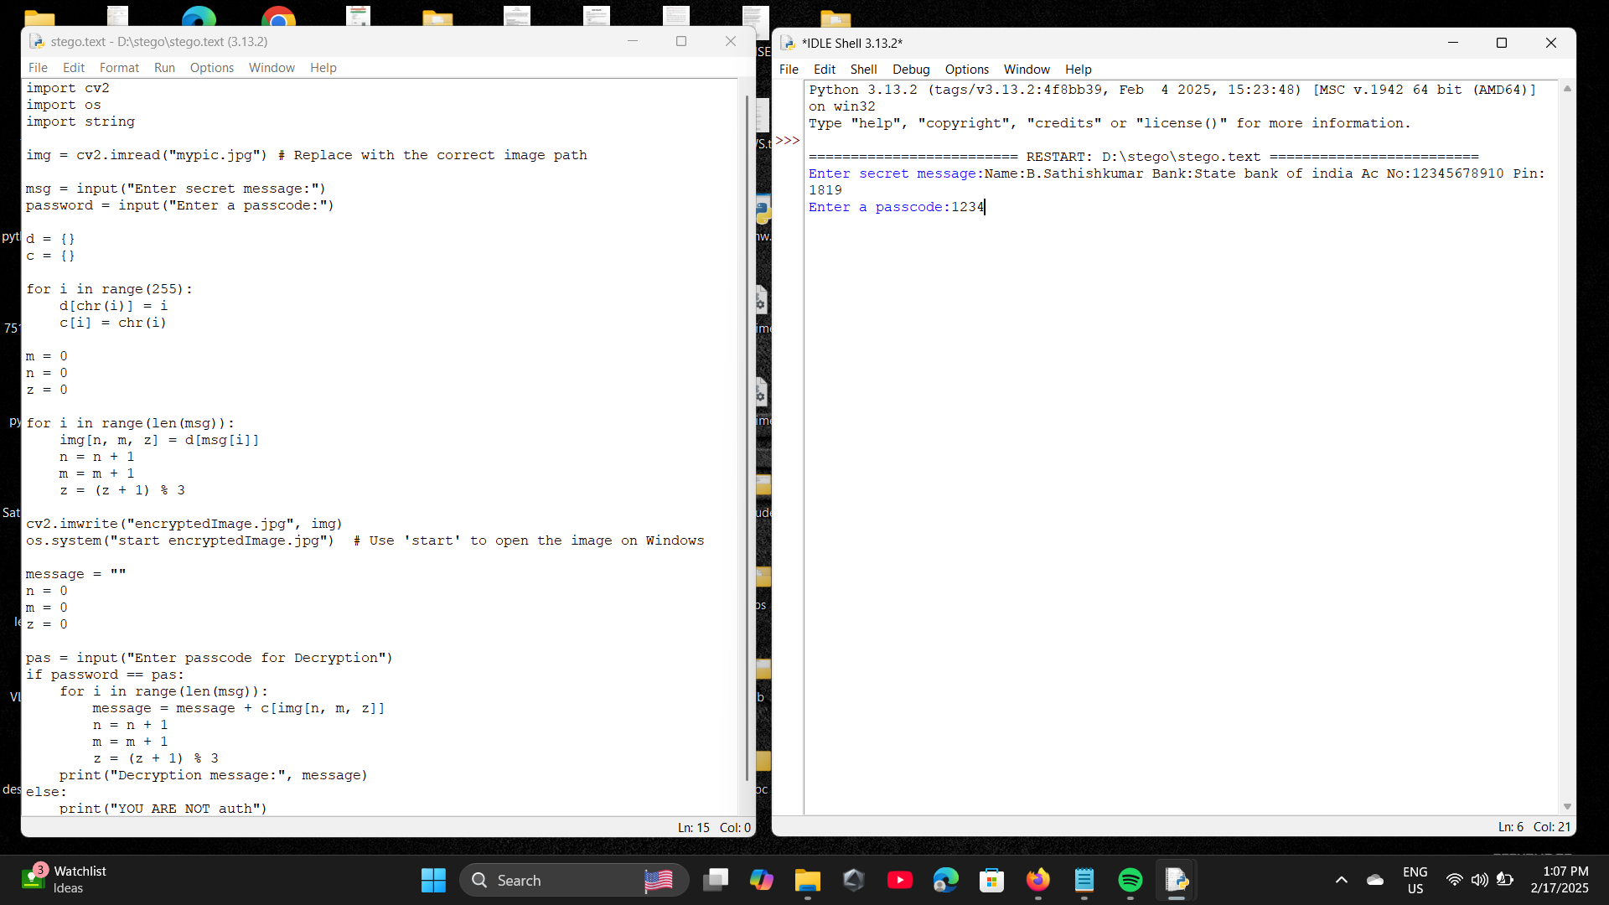RESULTS



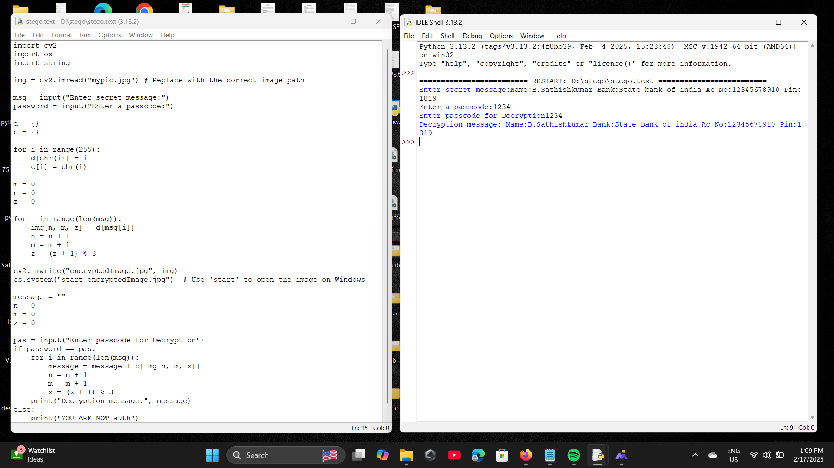

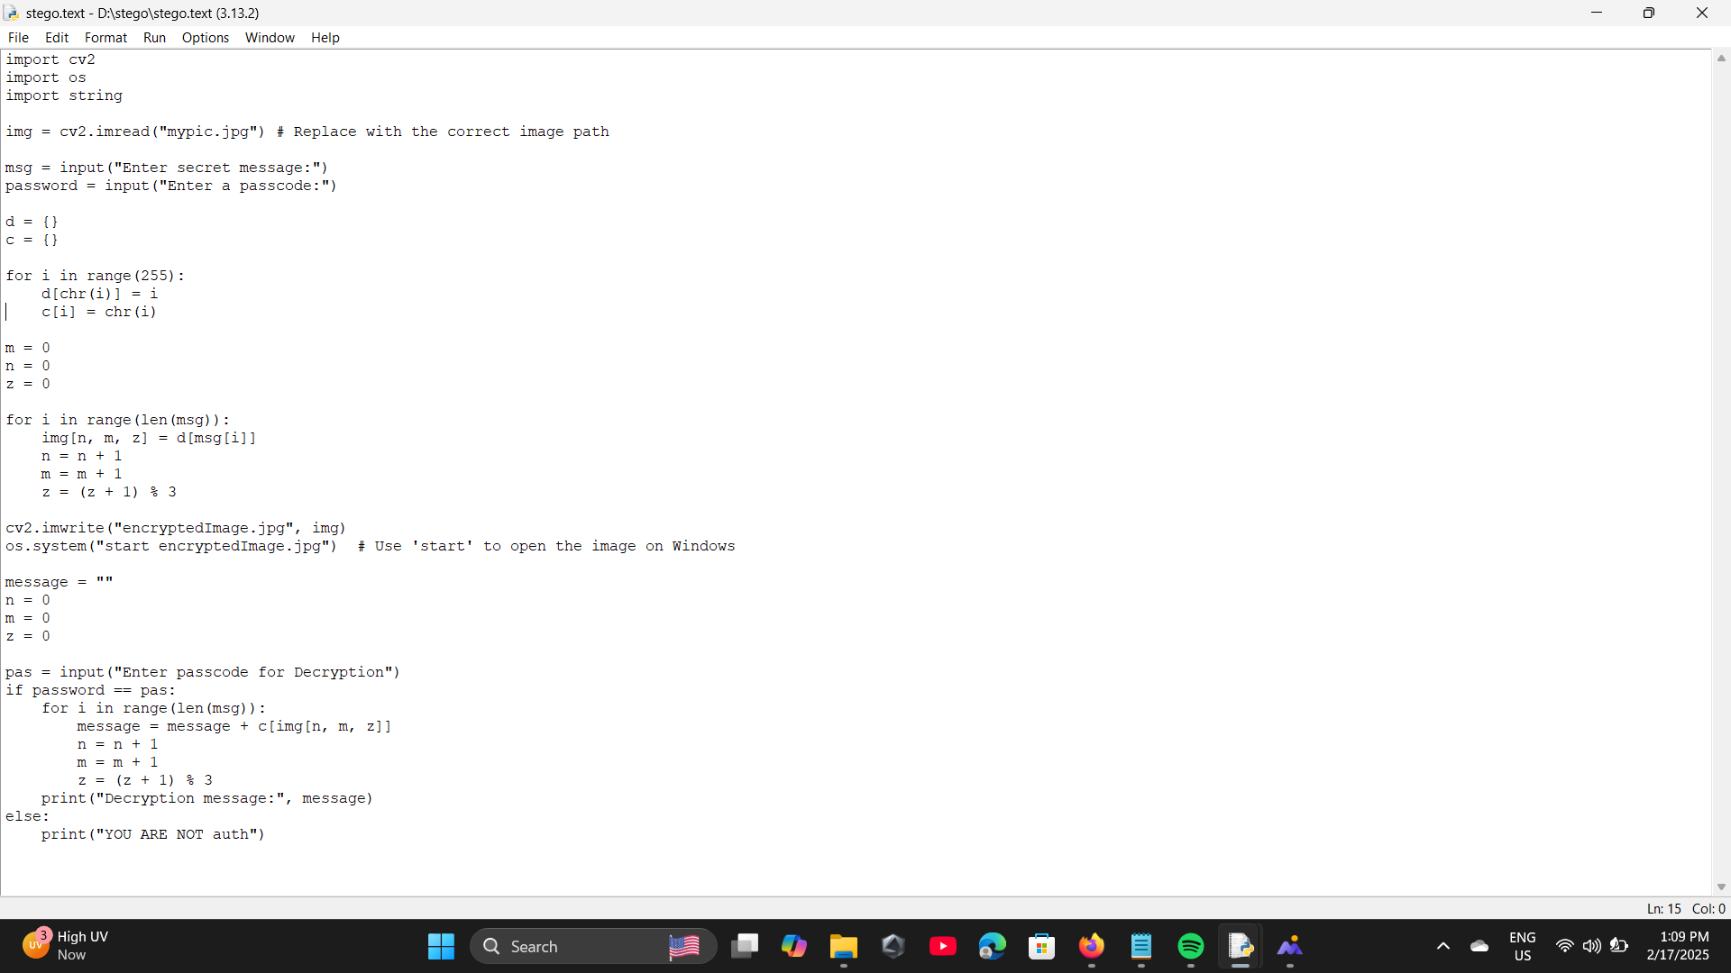

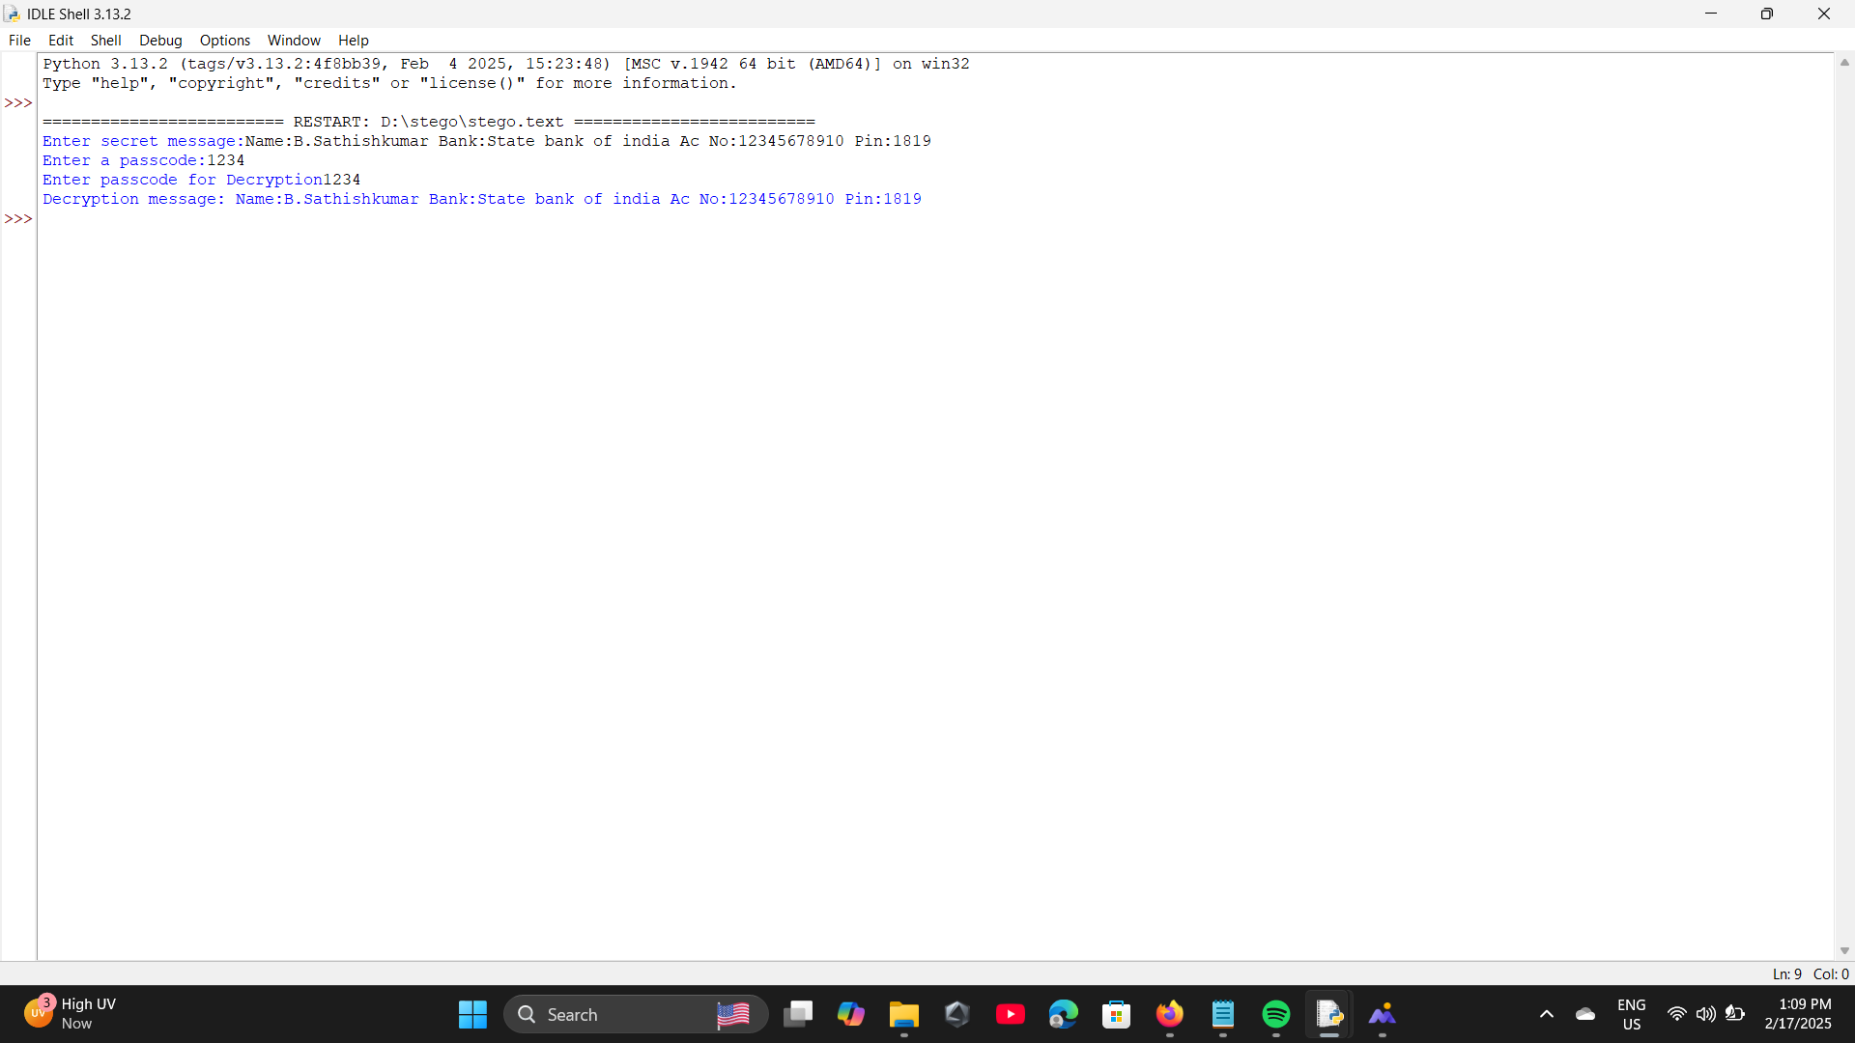

CONCLUSION

**Summary of Key Points:**

**Steganography offers a viable solution for secure data handling in images.**

**The technology is accessible and can be implemented with minimal resources.**

**Final Thoughts:**

**Importance of ongoing research and development in steganography. Encouragement for users to adopt secure data handling practices.**

GITHUB LINK

**https://github.com/SathishKumarsunny/AICTE-----project.git**

## FUTURE SCOPE(OPTIONAL)

## Advancements in Steganography:

## Development of more robust algorithms to resist

## detection.

## Integration with other security measures (e.g.,

## encryption).

## Potential Research Areas:

## Exploring steganography in video and audio files.

## Applications in emerging technologies (e.g., IoT,

## blockchain).

## Call to Action:

## Encourage collaboration and innovation in the field

## of secure data handling.

**THANK YOU**